Chip back potential is the level which bulk silicon is maintained by on-chip connection, or it is the level to which the chip back must be connected when specifically stated below. If no potential is given the chip back should be isolated.

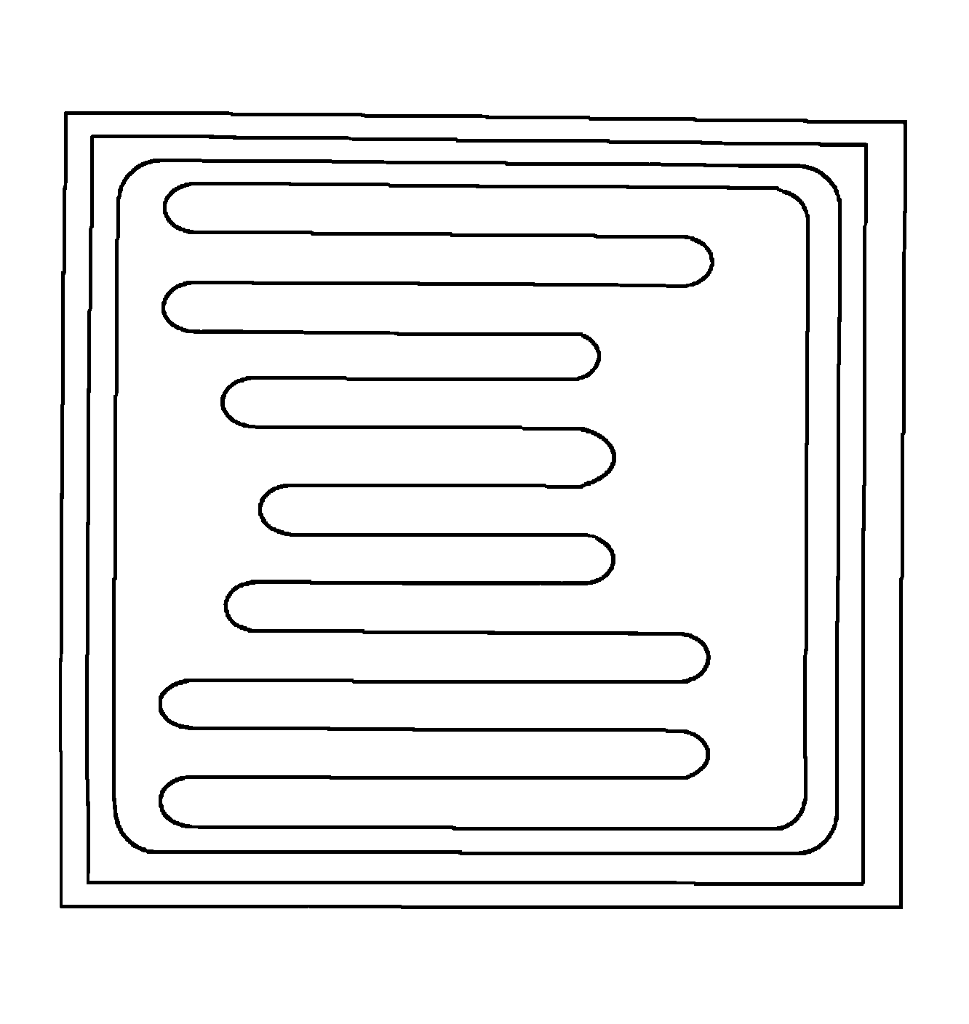
BASE
EMITTER
BACK SIDE IS COLLECTOR

Top Material: Al
Backside Material: TiNiAg
Bond Pad Size: .004” min.
Backside Potential: Collector
Mask Ref: AD07

APPROVED BY: DK DIE SIZE .097” X .097” DATE: 3/25/16
MFG: ON SEMI THICKNESS .013” P/N: MJEC15028 / 15029
DG 10.1.2

Rev B, 7/19/02

